Programming in C
Lab File
SESSION : 2024-27



Submitted to: |  | Submitted by:
Silky Goel |  | Ruchika Bhatt
 |  | SAP ID- 590016350
BCA Batch 5

INDEX

- Write a code to add two numbers also write the algorithm, pseudo code and draw flow chart.
- Write a code to find the area and circumference of a circle numbers, also write the algorithm, pseudo code and flow chart.
- Write a code to check whether the number is odd or even also write the algorithm, flow chart and pseudo code.
- Write a code to print first name, surname, birthyear in a sequence , also write the algorithm, flow chart and pseudo code.
- Write a code to print the simple interest, also write the algorithm, pseudo code and flowchart.
- Write a code for swapping two numbers using temporary variable also write the algorithm, flow chart and pseudo code.
- Write a code for swapping numbers without using temporary variable also write the algorithm, flow chart and pseudo code.
- Write the program to demonstrate the concept of size of operator such as character, integer, float and double.
- Write the program to find the largest among two numbers using the ternery operator.
- Write the program to check whether a year is leap year or not using the ternery operator.
- Write the program to read the value of an integer m and display the value of n 1 where m is larger than 0,0 when m is 0 and -1 when m<0.
- Write the programme to find the largest of 3 numbers.
- Write a programme to accept a grade and declare the equivalent description:
GRADE DESCRIPTION
E EXCELLENT
V VERY GOOD
G GOOD
A AVERAGE
F FAIL
- Write a programme to accept 2 integers whether they are equal or not.
- Write the program to display n terms of natural numbers and calculate their sum.
- Write the programme to display the multiplication table for a given integer.
- Write the programme to display the factorial of a given number.
- Write a program to read 10 number from keyboard and then find there sum and average.
- Population of a town is 1 lakh. The population has increased at the rate of 10% per year for the last years. Write a program to determine the population at the ned of each year in last decade.
- Write a program to generate the following set of output:
1
2 3
4 5 6
EXPERIMENT- 1

AIM: Write a code to find the sum of two numbers and write the algorithm, pseudo code and draw the flowchart.
SOURCE CODE:
#include<stdio.h>
int main( ) {
int a, b, sum;
printf (“Enter two integers”)
scanf (“%d %d”, &a &b);
sum = a+b;
printf (“%d + %d = %d”, a, b, sum);
}

OUTPUT:
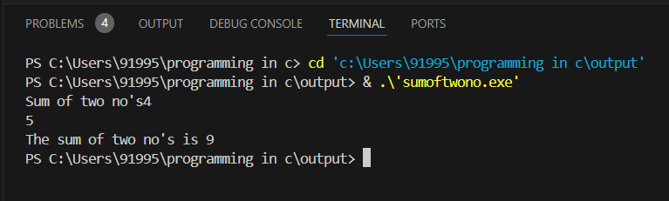

ALGORITHM:
Step 1: Start
Step 2: Read the first number.
Step 3: Read the second number.
Step 4: Add the two numbers using add operator.
Step 5: Display the result.
Step 6: Stop

FLOWCHART:
Read num 1
Print Sum
Stop
Start
Sum= num1 + num2
Read num 2

EXPERIMENT- 2

AIM: Write the program to calculate the area and circumference of the circle. Also write the algorithm, pseudo code and draw the flow chart.
SOURCE CODE:
- #include <stdio.h>
- #define PI 3.14159
- int main() {
- double radius, area, circumference;
- printf("Enter the radius of the circle: ");
- scanf("%lf", &radius);
- area = PI * radius * radius;
- circumference = 2 * PI * radius;
- printf("Area of the circle: %.2lf\n", area);
- printf("Circumference of the circle: %.2lf\n", circumference);
- return 0;
- }

OUTPUT:
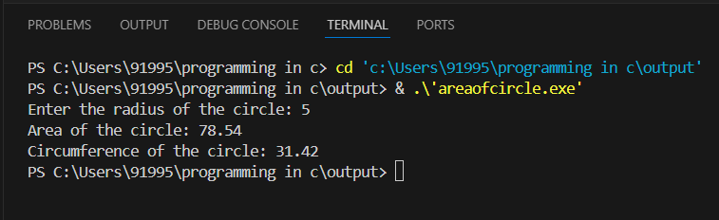

ALGORITHM:
• Start
• Input radius of the circle (r)
• Calculate area using the formula: Area = π * r^2
• Calculate circumference using the formula: Circumference = 2 * π * r
• Output the area and circumference
• Stop

FLOWCHART:
Print Area
Stop
Start
Print Circumference
Circumference=2*pi*radius
Area =pi*radius*radius
Let pi= 3.14
Read radius

EXPERIMENT- 3
AIM: Write a code to check whether the number is odd or even also write the algorithm, flow chart and pseudo code

SOURCE CODE:
#include <stdio.h>
int main(){
int num;
printf("Enter the number ");
scanf("%d", &num);
if (num % 2 == 0)
printf("%d Even",num);
else printf("%d odd",num);
return 0;
}

OUTPUT:
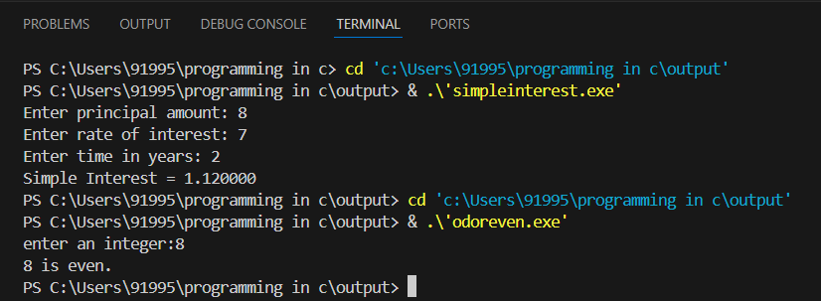

ALGORITHM:
Step 1: Start
Step 2: Take a number n from the user.
Step 3: Calculate remainder by using n%2.
Step 4: If the remainder is 0 print “even”
Step 5: If the remainder is not 0 print “odd”
Step 6: Stop

FLOWCHART:
Enter a number n
If n%2==0
Start

YES
NO
Number is odd
Stop
Number is even

EXPERIMENT- 4
AIM: Write a code to print first name, surname, birthyear in a sequence , also write the algorithm, flow chart and pseudo code.

SOURCE CODE:
#include<stdio.h>
int main()
{
char firstname[20],surname[20];
int birthyear;
printf("Enter first name: ");
scanf("%s",&firstname);
printf("Enter surname: ");
scanf("%s",&surname);
printf("Enter birthyear: ");
scanf("%d",&birthyear);
printf("%s ",firstname);
printf("%s",surname);
printf("\n%d",birthyear);
return 0;
}

OUTPUT:
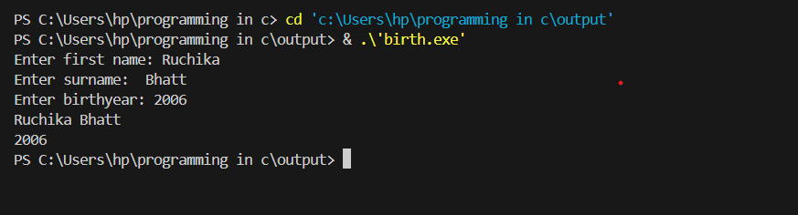

ALGORITHM:
Step 1: Start
Step 2: Take first name from the user
Step 3: Take surname from the user
Step 4: Take birthyear from the user
Step 5: Print name
Step 6: Print surname
Step 7: Print birthyear
Step 8: Stop
FLOWCHART:
Enter surname
Start
Enter birthyear
Enter first name

Print “Surname”

Print “First name”

Print “Birthyear”

Stop

EXPERIMENT – 5

AIM: Write the program for calculating the simple interest. Also write the algorithm, pseudo code and draw the flow chart.

SOURCE CODE:
#include <stdio.h>

int main() {
float principal, rate, time, si;
printf("Enter principal amount: ");
scanf("%f", &principal);
printf("Enter rate of interest: ");
scanf("%f", &rate);
scanf("%f", &time);
si = (principal * rate * time) / 100;
printf("Simple Interest = %f", si);
return 0;
}

OUTPUT:
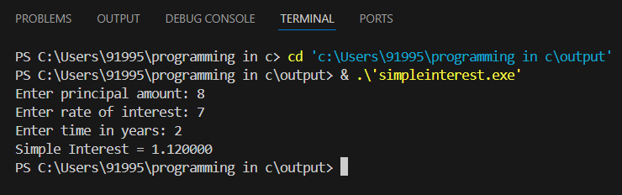

ALGORITHM:
Step 1: Start
Step 2: Take P from the user
Step 3: Take R from the user
Step 4: Take T from the user
Step 5: Calculate Simple Interest using the formula P*R*T/100
Step 6: Display Simple Interest
Step 7: Stop

FLOW CHART:
Start
Enter P
Enter T
S.I=P*R*T/100
Print S.I
Stop
Enter R

EXPERIMENT- 6

AIM: Write a code for swapping numbers using temporary variable. Also write the algorithm, flow chart and pseudo code.
SOURCE CODE:
#include <stdio.h>

int main() {
int a, b, temp;

printf("Enter two numbers: ");
scanf("%d %d", &a, &b);

temp = a;
- = b;
- = temp;

printf("Swapped numbers: a = %d, b = %d\n", a, b);

return 0;
}

OUTPUT:
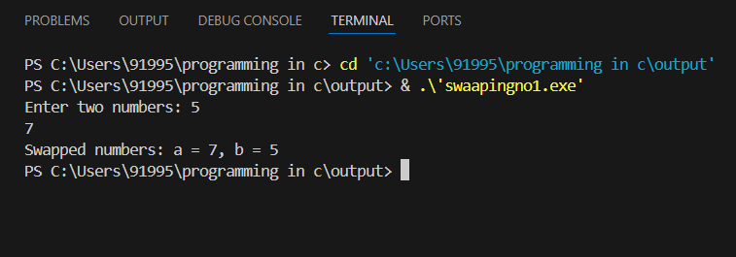
ALGORITHM:
Step 1:Start
Step 2: Take a number a from the user
Step 3: Take a number b from the user
Step 4: Create a temporary variable c
Step 5: Assign the value of a to c
Step 6: Assign the value of b to a
Step 7: Assign the value of c (which holds the original value of a) to b
Step 8: Display the swapped values of a and b
Step 9: Stop

FLOWCHART:
Start

Enter a

Enter b

c=a

a=b

b=c
Print a
,b

Stop

EXPERIMENT - 7

AIM: Write a code for swapping numbers without using third variable also write the algorithm, flow chart and pseudo code.

SOURCE CODE:
#include <stdio.h>

int main() {
int a, b;

printf("Enter two numbers: ");
scanf("%d %d", &a, &b);

printf("Before swapping: a = %d, b = %d\n", a, b);
a = a + b;
b = a - b;
a = a - b;

printf("A er swapping: a = %d, b = %d\n", a, b);

return 0;
}

OUTPUT:
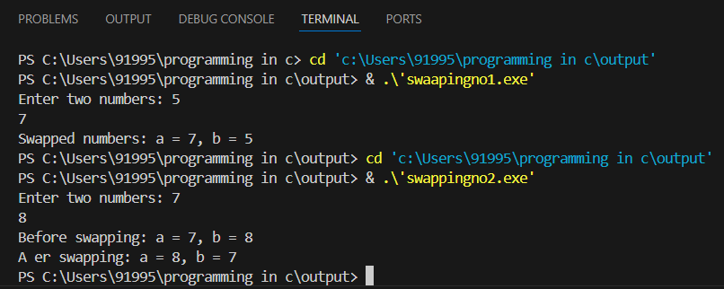

ALGORITHM:
Step 1: Start
Step 2: Take ‘a’ from the user
Step 3: Take ‘b’ from the user
Step 4: Swap using arithmetic operations
Step 5: Update ‘a’ using a = a + b
Step 6: Update ‘b’ using b = a – b
Step 7: Update ‘a’ using a = a – b
Step 8: Print the swapped values of a and b
Step 9: Stop

FLOWCHART:

Start

Enter a

Enter b

a=a + b

b=a – b
a= a - b
Print a, b

Stop

EXPERIMENT-8

AIM: Write the program to demonstrate the concept of size of operator such as character, integer, float and double..

SOURCE CODE:
#include <stdio.h>

int main() {
int a;
char b;
float c;
double d;
printf("size of int :%lu\n”,sizeof(a));
printf("size of char :%lu\n",sizeof(b));
printf("size of float :%lu\n",sizeof(c));
printf("size of double :%lu\n",sizeof(d));

return 0;
}
OUTPUT:
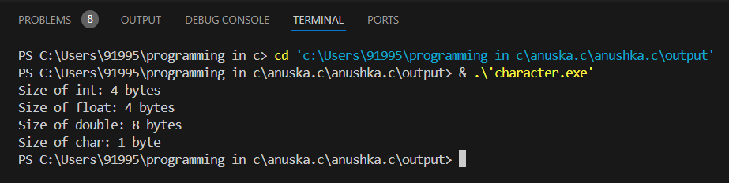

EXPERIMENT – 9

AIM: Write the program to find the largest among two numbers using the ternary operator.
SOURCE CODE:
#include <stdio.h>

int main(){
int x,y;
int largest;
printf("enter two numbers ");
scanf("%d %d",&x,&y);
largest = (x > y)? x : y;
printf("the largest number is %d ",largest);
}

OUTPUT:
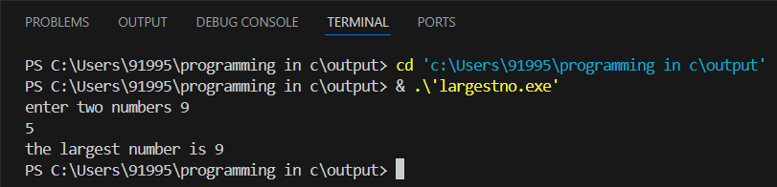

EXPERIMENT – 10

AIM: Write the program to check whether a year is leap year or not using the ternary operator.
SOURCE CODE:
#include <stdio.h>

int main() {
int year;
printf("Enter a year: ");
scanf("%d", &year);

int leap = (year % 4 == 0 && (year % 100 != 0 || year % 400 == 0));

printf("%d is %s a leap year.\n", year, leap ? "": "not");

return 0;
}

OUTPUT:
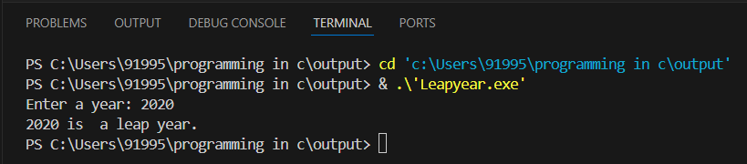

EXPERIMENT-11

AIM: Write the program to read the value of an integer m and display the value of n 1 when m is larger than 0,0 when m is 0 and -1 when m < 0.

SOURCE CODE:
#include <stdio.h>
int main(){
int m,n;
prin ("Input the value of m: ");
scanf("%d",&m);
if(m!=0){
if (m>0)
n=1;
else
n=-1;
}
else
n=0;
printf("The value of m = %d ",m);
printf("The value of n = %d ",n);

return 0;
}
OUTPUT:
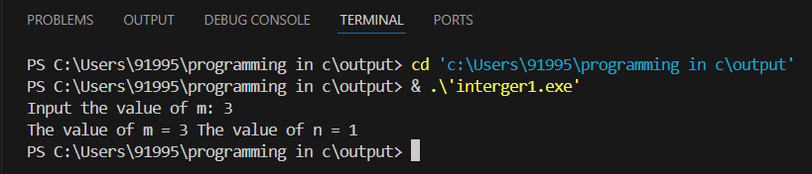
EXPERIMENT 12
AIM: Write the programme to find the largest of 3 numbers.

SOURCE CODE:
#include <stdio.h>

int main(){
int x,y,z;
int largest;
printf ("enter three numbers ");
scanf("%d %d %d",&x,&y,&z);
largest = (x > y) ? ((x > z) ? x : z) : ((y > z) ? y : z);
printf ("the largest number is %d ",largest);
}
OUTPUT:
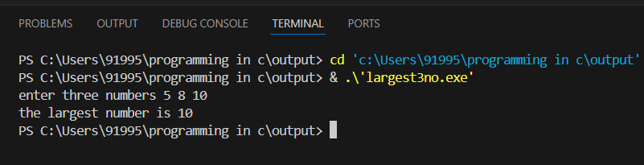

EXPERIMENT 13
AIM: Write a programme to accept a grade and declare the equivalent description:
GRADE Description
E Excellent
V Very Good
G Good
A Average
F Fail

SOURCE CODE:
#include <stdio.h>
int main(){
char a;
printf ("Enter the grade ");
scanf("%c",&a);
if (a == 'E')
printf ("Excellent");
else if (a == 'V')
printf("Very Good");
else if (a == 'G')
printf ("Good");
else if (a == 'A')
printf ("Average");
else if (a == 'F')
prin ("Fail"); else
printf ("Invalid Input");

return 0;
}
OUTPUT:
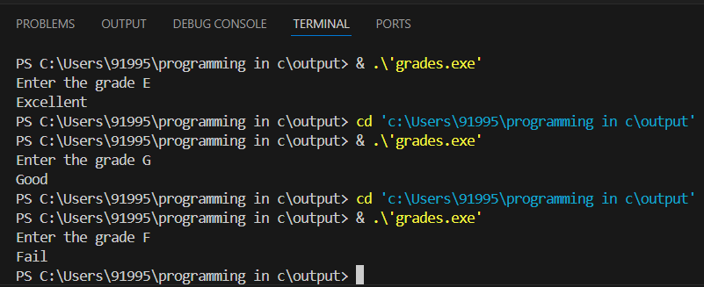

EXPERIMENT 14
AIM: Write a programme to accept 2 integers whether they are equal or not.
SOURCE CODE:
#include <stdio.h>

int main(){
int a,b;
printf ("Enter two integers: ");
scanf("%d %d",&a,&b);
if (a == b){
printf ("Equal");
}
else
{
printf ("Not Equal");
}
return 0;
}
OUTPUT:
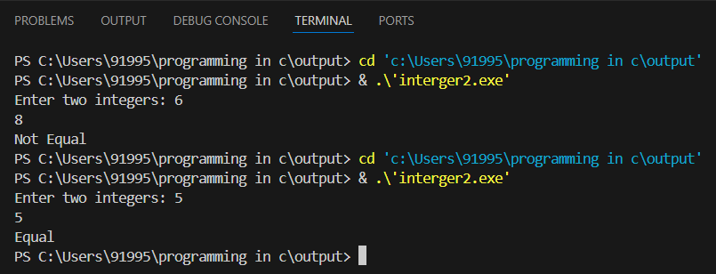

EXPERIMENT 15
AIM: Write the program to display n terms of natural numbers and calculate their sum.
SOURCE CODE:
#include <stdio.h>
int main() {
int n;
printf ("Enter the value of n: ");
scanf("%d", &n);

if (n <= 0) {
printf ("Please enter a positive integer for n.\n”);
return 1;
}
int sum = 0;
for (int i = 1; i <= n; ++i) {
printf ("%d ", i);
sum += i;
}
printf ("\nThe sum of the first %d natural numbers is %d.\n", n, sum);

return 0;
}
OUTPUT:
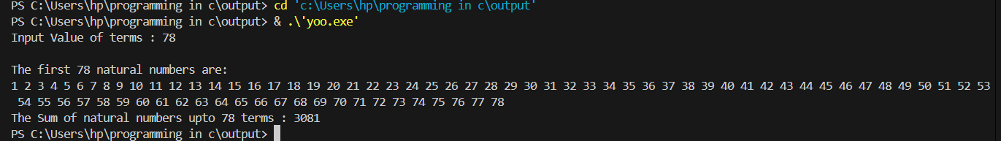

EXPERIMENT 16
AIM: Write the programme to display the mul plica on table for a given integer.
SOURCE CODE:
#include <stdio.h>

int main() {
int num;
printf("Enter an integer: ");
scanf("%d", &num);

printf("Multiplication on table for %d:\n", num);
for (int i = 1; i <= 10; ++i) {
prin ("%d x %d = %d\n", num, i, num * i);
}

return 0;
}
OUTPUT:
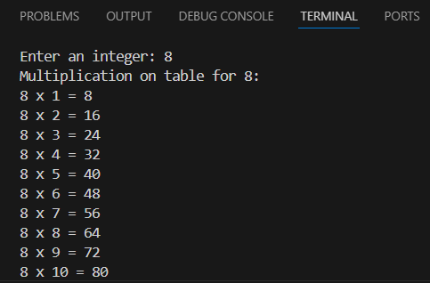

EXPERIMENT 17
AIM: Write the programme to display the factorial of a given number
SOURCE CODE:
#include <stdio.h>
int main(){
int n, fact = 1;
printf("Enter a number: ");
scanf("%d", &n);
for (int i = 1; i <= n; ++i)
{
fact = fact*i;
}
printf("The factorial of natural numbers is: %d.\n",fact);
return 0;
}
OUTPUT:
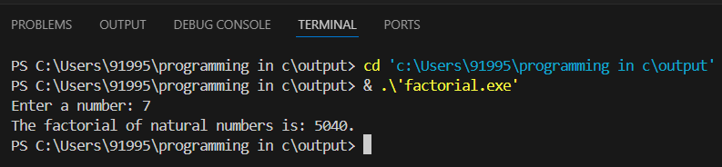

EXPERIMENT 18
AIM:Write a program to read 10 number from keyboard and then find there sum and average .
SOURCE CODE:
#include <stdio.h>
int main(){
int n[10];
int sum=0;
int a=1;
for(int i=1;i<=10;i++)
{
printf("enter a number :");
scanf("%d",&n[i]);
sum+=n[i];
}
printf("sum = :%d",sum);
int avg=sum/10;
printf("\naverage is :%d",avg);
}
OUTPUT:
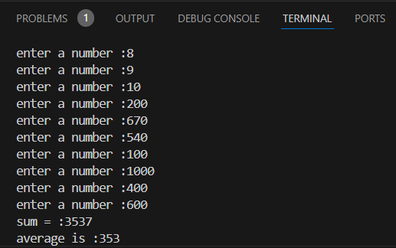

EXPERIMENT 19
AIM: Population on of a town is 1 lakh. The population on has increased at the rate of 10% per year for the last 10 years. Write a program to determine the population on at the ned of each year in the last decade.
SOURCE CODE:
#include <stdio.h>
int main() {
int initialPopulation= 100000;
double growthRate = 0.10;
int years = 10;
printf ("Year\tPopulation\n");
for (int year = 1; year <= years; ++year)
{
double population = initialPopulation * (1 + growthRate);
initialPopulation = population;
printf ("%d\t%.0lf\n", year, population);
}
return 0;
}
OUTPUT:
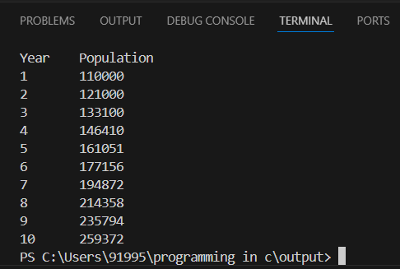

EXPERIMENT 20
AIM:Write a program to generate the following set of output:
1
2 3
4 5 6
SOURCE CODE:

#include <stdio.h>
int main() {
int i,j, c=1, n;
printf ("enter number of terms\n");
scanf("%d",&n);
for(i=1;i<=n;i++)
{ for(j=1;j<=i;j++)
{ printf (" %d",c);
c++;
}
printf ("\n");
}
}

OUTPUT:
